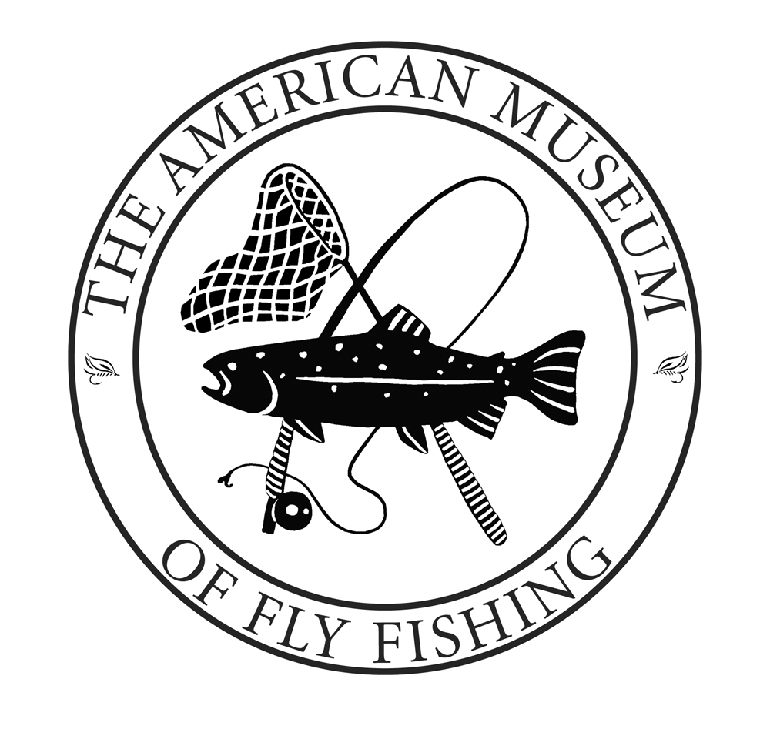

***2017 Fly Fishing Festival***

Saturday, August 12

on the grounds of the

American Museum of Fly Fishing

Manchester, Vermont

Come celebrate the thrills of fly fishing and join the many vendors and demonstrators who participate in our premiere annual event. Don’t miss out on this day of fly fishing, sun, and fun.

*Online Registration is available by logging onto the website www.amff.org

Onli

lxo

**Option 1:** Space under the tent includes an 8 foot table, 2 chairs and a navy tablecloth for the cost of $55!

**Option 2:** Space on the green surrounding the tent is available for those with a personal tent for $25 (10x10ft). We are offering rentals tables, chairs ($12) and tablecloths ($5).

Any further questions please contact Pete Nardini, at 802-362-3300

To register, please mail in this completed form to the address below:

**Name: _______________________Business:______________________**

**Address: _____________________C/S/Z: ________________________**

**Email: ______________________ Phone: ________________________**

**Business Type: _________________________**

**Guest: ___________________**

**Option 1:**

Number of tables under tent (x$55) $____________

Electricity? – Y/N ($5) $____________

**Option 2:**

Personal Tent (x$25) $____________

8 foot table and 2 chairs ($12) $____________

Electricity needed? – Y / N ($5) $____________

Tablecloth ($5) $____________

**Total Due** **$____________**

Make checks payable to AMFF or pay by VISA/MC/AMEX:

Card # ________________________________________

Exp. Date ________________ Security Code ______________

